BOSNIAN VALLEY OF PYRAMIDS

- SCIENTIFIC EVIDENCE ABOUT THE EXISTENCE OF BOSNIAN PYRAMIDS -

Existence of monumental pyramidal complex in Central Bosnia had caught the world public by surprise and shook the global scientific community because it may require a part of the world history to be rewritten.

Discovery of Bosnian Pyramids was not simply an ad-hoc affair, but required combination of classic geo-archaeological methods with modern geophysical and remote sensing technologies.

The Archaeological Park Foundation believes that only a multi-disciplinary approach, with serious scientific argumentation on internationally recognized level will yield a successful realization of the Bosnian Pyramids project.

The team, therefore, includes not only archaeologists, but also geologists (mineralogists/petrologists, hydrologists and sedimentologists), geophysicists, paleontologists, speleologists, anthropologists, mining engineers as well as anthropologists. Each one of these experts brings a new element of problem understanding and integrate their qualifications and expertise into the project with a great enthusiasm and collegiality.

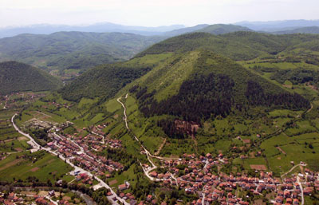

Bosnian Pyramid of the Sun

Scientific evidence presented thus far (full reports available at www.piramidasunca.ba):

1. GEOMETRIC FEATURES OF THE PYRAMIDS

Based on numerous airborne and spaceborne imagery of mound Visocica – Bosnian Pyramid of the Sun, it becomes evident that the geometric features suggest two or more sides exhibit geometrical shape of a triangle. Even though such elements occur in the nature, it is rarely, if ever, a precise shape and rarely replicated on opposite sides of a mound. In this case, two sides are equilateral triangles, with well defined sides.
Satellite imaging of the general locality in the central part of Bosnia and Herzegovina (Landsat, Radarsat, Hyperion, Ikonos) indicated that there are five hills which show apparent geospatial anomalies where two or more sides are triangular. All of the aforementioned hills exhibit triangular sides and some have elements of stairs-step features on the sides with flat plateaus on the top.
In the case of Visocica, three out of four sides exhibit evidence of geometric features. Geologic evidence is not indicative of any significant faulting or glaciation processes in the area that would otherwise effect the existence, geometry and texture of these sides. Measurements made by the Geodetic Institute of Bosnia and Herzegovina suggest that northern portion of Visocica/Bosnian Pyramid of Sun is forming geometric feature of triangle, with equal sides of 365 meters and inner angles of 60 %.

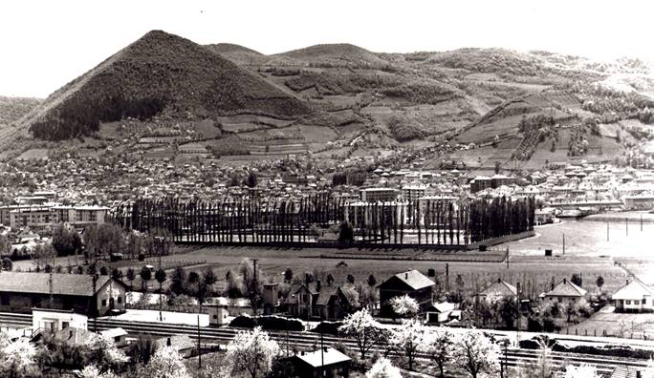

Figure 1: Bosnian Pyramid of the Sun, Visoko, Bosnia and Herzegovina

2. ORIENTATION - CARDINAL SIDES OF THE WORLD

Measurements made by the Geodetic Institute of Bosnia and Herzegovina indicate that the sides of Visocica/Bosnian Pyramid of Sun are exactly aligned with the cardinal sides of the world (north-south, east-west), which is one of the characteristics often noted with the existing pyramids. North side of the mound is oriented towards stellar north (like the Great Pyramid of Egypt), in parallel with position of the North Star.

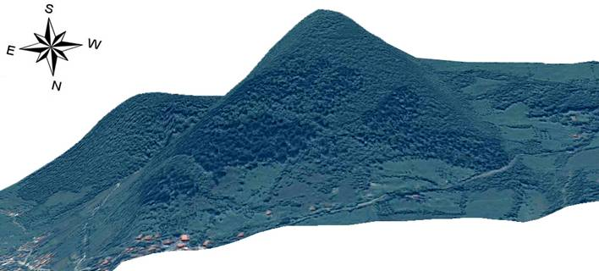

Picture 2: Satellite topography of Bosnian Pyramid of Sun and orientation toward sides of the world

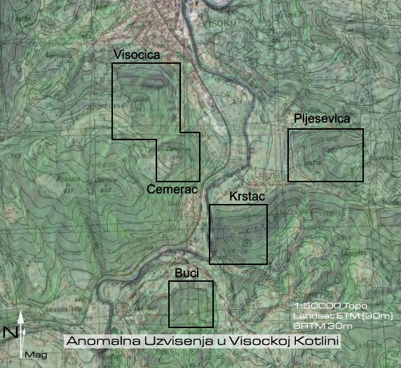

Figure 3: Location of geospatial “anomalies” or pyramids, on topographic map with their exact orientation with cardinal NSWE directions.

3. APPARENT THERMAL INERTIA MEASUREMENTS

The results of the thermal inertia obtained from ASTER thermal detector (resolution 60m) suggest that the observed targets may be comprised of less consolidated material and tend to “cool faster” respective to their surroundings (presumed denser). The findings would be consistent with initial field observations noted in the Geological Report, and also recent excavations on site. The results appear consistent with what would be expected from an artificial structure – lesser density materials, porosity, internal cavities/chambers, hallways etc. all contribute to an increased heat loss.

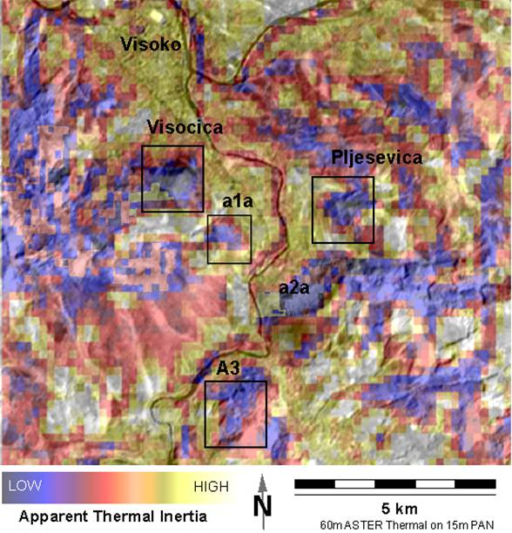

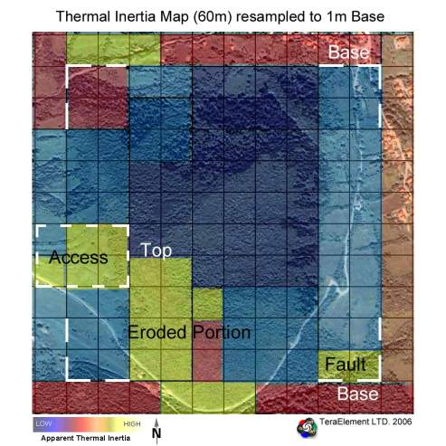

Figure 4b: Resampled ASTER data to Visocica 1m color image data. Squares represent 60m pixels. Note that the anomaly (pyramid sides) is narrowly defined.

4. GEOLOGICAL-SEDIMENTARY ANALYSES

The results of core drilling, test-well sinking and limited trenching in August and October 2005, with follow up in 2006 have confirmed prior observations and also revealed that the surface of the mound is comprised of layered sandstone and breccia blocks, which appear to have been manually processed and/or cut to fit the required dimensions. The binding agent found between the sandstone blocks suggest the presence of a “clastic breccia,” a multicolored conglomerate comprised out of gravel, sandstone and shale with a connective matrix or cement composed of sandy carbon particles of quartz, feldspar and flakes of mica. The flat sides of the blocks, the contact zone and the binding agent are clearly visible. Further detailed cleaning of the contact line between the two sandstone blocks revealed that the blocks were manually processed beneath and that the surface was flat and smooth, with binding agent applied afterwards to the surface. The order of the blocks itself supports the finding: they were ordered like bricks in a brick wall - the upper block was moved inwards in relation to the lower one

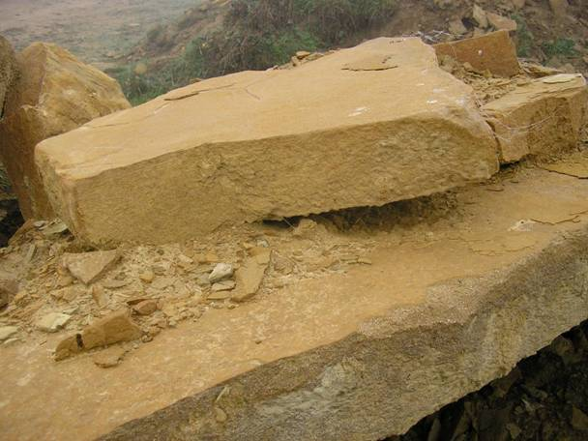

Figure 5: Sandstone monoliths, shaped by human hand and emplaced at the monumental access plateau

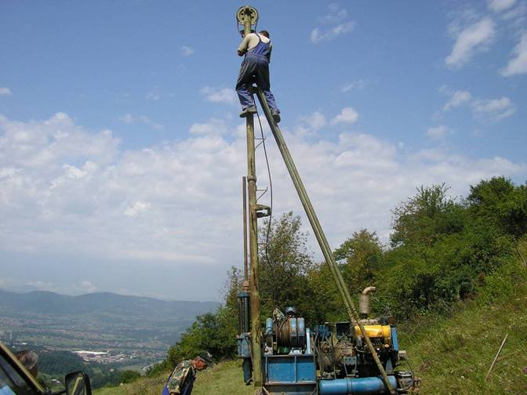

Figure 6: Geological core drilling done in August 2005

5. GEODETIC TOPOGRAPHIC COUNTOUR ANALYSIS

High resolution elevation contour interval map indicates even overall slope and stair-step design observable on the sides of Visocica/Pyramid of the Sun.

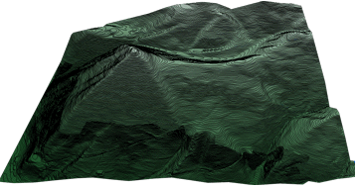

Figure 7: 3-d geodetic countour interval map of the Bosnian Pyramid of the Sun (Courtesy: Geodetic Institute of Bosnia and Herzegovina).
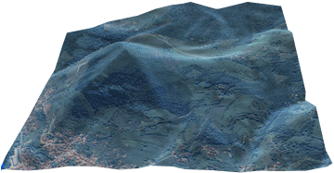

6. LINEAMENT DETECTION

The automated linear-anomaly detector LINANAL (originally developed for tectonic studies of topographic lineaments) estimated the break angles of 43.822 degrees (+/- 1.6) on the exposed facets, repeated within the same error envelope on all exposed sides The observed phenomena should not be confused with triangular facets normally occurring in a tectonic setting, for those occurrences only exhibit single-side triangulation and are uneven in the appearance with a far lesser or greater incidence angle, whereas the observed anomalies exhibit two or more, even triangular sides with 4, ~~ 40-48 degree angular breaks. Furthermore, no observed fault strikes correspond with the triangular occurrences on the mounds, thus eliminating the possibility that they were a secondary product of recent tectonic movements.

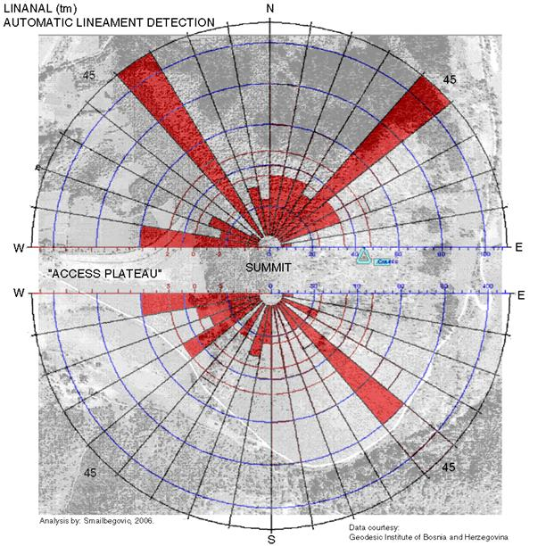

Figure 8: Results from automated lineament detection on the available, high resolution data sets over Bosnian Pyramid of the Sun (and image base for a quick reference). Note that the preferential orientation of the lineaments.

7. FLUVIAL GEOMORPHOLOGY

The geomorphic characteristics of the mound suggest that after periods of climbing under the same angle one reaches a flat plateau, approximately 2.5 meters wide, then another steep area follows, followed by another plateau, with the pattern repeated all the way to the top of Visočica. The drainage from the structure is localized almost exclusively to the edges, unlike on a natural mound, where water tends to flow haphazardly down the easiest path. Comparative analysis with the hills of similar shape and elevation supports this observation

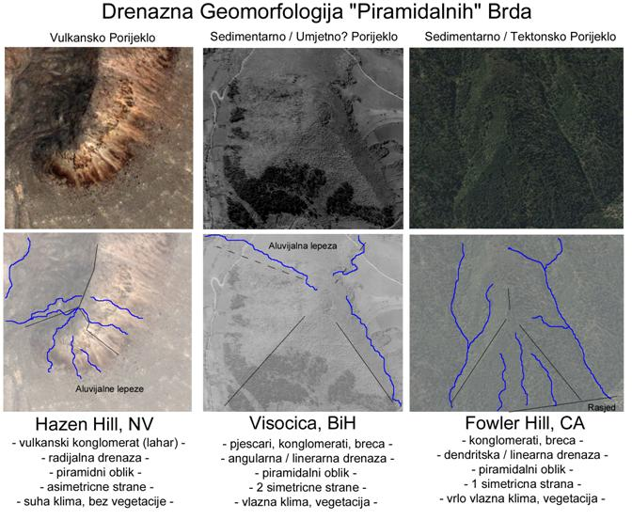

Figure 9: Comparative fluvial geomorphologic analysis – note channeling of water drainage from Visocica/Bosnian Pyramid of the Sun.

8. RADAR ANALYSIS

Combined radar analysis from RADARSAT and SPOT radar system suggest that there are apparent lineaments present on Bosnian Pyramid of the Sun and access plateau which may be indicative of buried terraces, walls and/or passageways/entrances or cavities,chambers inside of the structure. Additionally, artificial illumination of the radar-based topography suggest that the pyramids preserve their unusual shape even when illuminated from other directions.

This thesis is reinforced by numerous statements of the military personnel stationed on the Pyramid itself and subjected to heavy shelling. They have reported unusual ground vibrations, echoing and ground movement whenever the mound was hit by the artillery fire in the course of war operations in Bosnia between 1992-95. This acoustic evidence suggest that cavities/chambers may indeed exist within the structure.

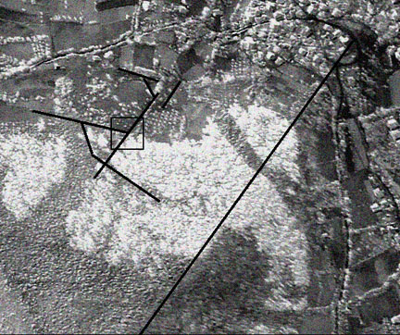

Figure 10: Anomalies/artificial hallways

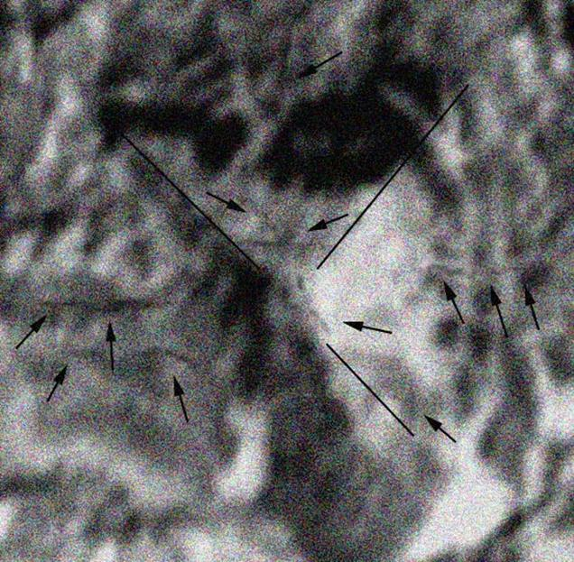

Figure 11: Combined RADARSAT and SPOT imagery over Visocica. Noted black lines represent either processing artifacts in the data or may be indicative of surface manifestations of buried cavities/terraces. Similar anomalies are not noted on other electro-optical data.

9. EQUILATERAL TRIANGLE OF 3 MAIN PYRAMIDS

Analysis of satellite imagery suggested that the three main pyramids in the Bosnian Pyramid Valley form an equilateral triangle. The independent verification of this hypothesis came from the Kadastral Office from the County of Visoko, who after precise GPS measurements of the hilltops determined that all angles are symmetric (60 degrees) and that the distances among all three hilltops are the same.

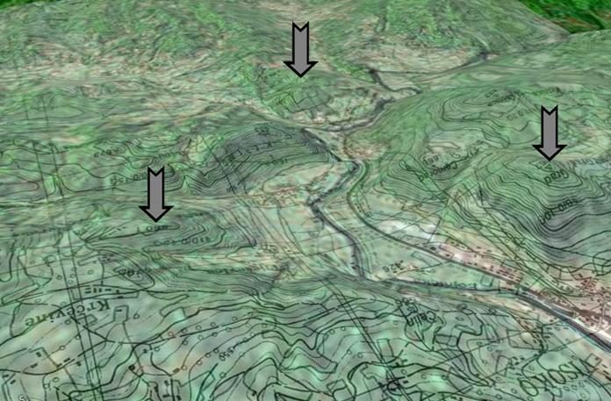

Figure 12: Topographic chart (1:24,000) with all three locations (Bosnian pyramids of the Sun, Moon and Dragon) and equilateral triangle they form over the valley.

10. ARCHAEOLOGIC / GEOLOGIC EVIDENCE – FIELD CAMPAIGN 2006 (in progress) – BOSNIAN PYRAMID OF THE SUN

Physical material evidence of shaped and well preserved stone monoliths, shaped and transported to this location and used for the construction of the pyramid walls. These monoliths were unearthed during the ongoing geo-archaeologic campaign April 14, 2006 – October 29, 2006.

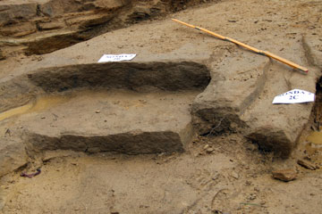

Figure 13: Access plateau from the west

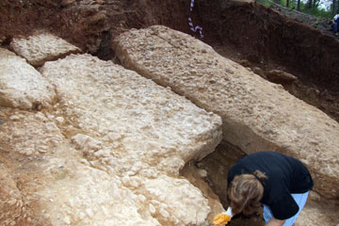

Figure 14: Monoliths on the northern side which form the walls of the Bosnian pyramid of the Sun

11. TUNNEL EVIDENCE

Numerous field evidence suggests that an extensive tunnel network exists in the valley. Principal investigator Sam Osmanagich claims that the tunnels system connects all of the colossal objects in the Bosnian Valley of Pyramids. The works are currently in progress, but already several shaped monoliths have been found in the tunnels.

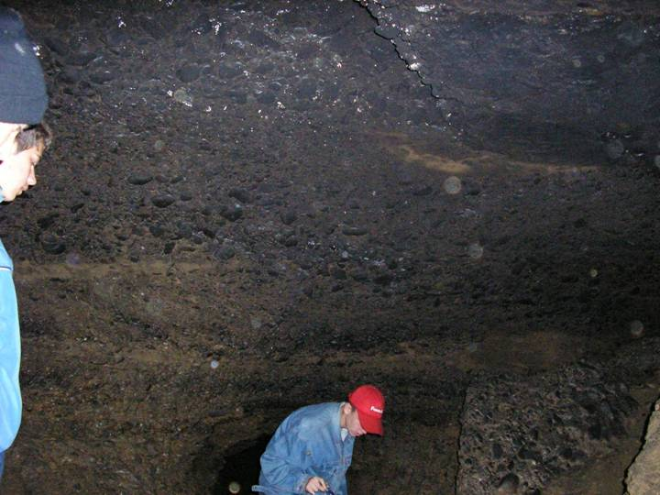

Figure 15: Ceiling in the tunnels indicate their artificial origin.

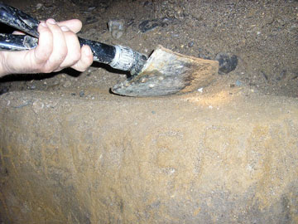

Figure 16: Apparent shaped sandstone monolith found at the 185th meter of the tunnel in Ravne, under a thick layer of conglomerate and sand indicating its fairly old age of emplacement. The weight of the monolith is presumed to be over 7 metric tones and it is yet to be completely unearthed.

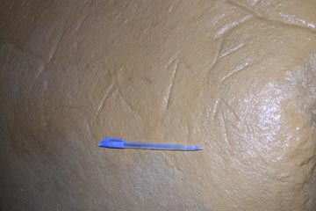

Figure 17 – Ancient writings found on sandstone monoliths in the tunnel

12 – BOSNIAN PYRAMID OF THE MOON

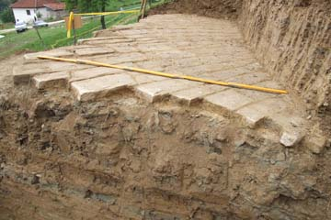

Figure 18: Bosnian Pyramid of the Moon – sandstone plates, nicelly shaped and fit next to each other

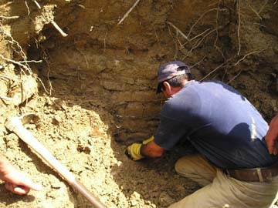

Figure 19: Bosnian Pyramid of the Moon – vertical wall, built from sandstone plates

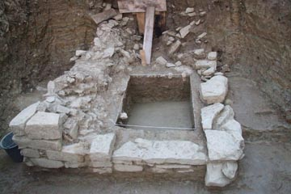

Figure 20: Bosnian Pyramid of the Moon – rectangular structure, sandstone plates

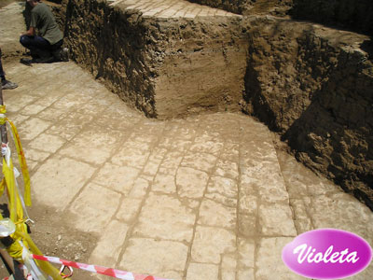

Figure 21: Bosnian Pyramid of the Moon – sandstone plates, four raws on top of each other, possible foundation of the pyramid

